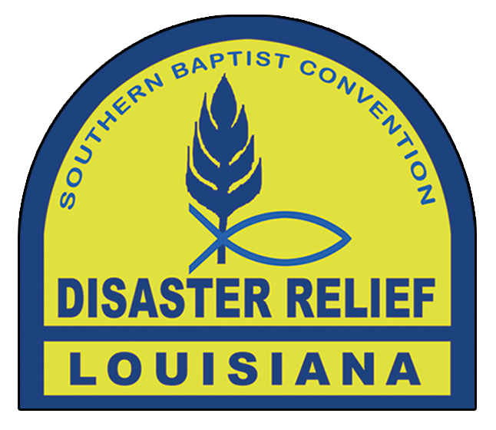
Disaster Relief Donations

5 Gallon Bucket With Lid
- Masks (MUST BE N95 DUE TO MOLD SAFETY)
- 32 oz disinfecting cleaner (Pine Sol, etc)
- 32 oz liquid dish soap
- 32 oz spray cleaner (with bleach)
- 2 sponges
- Pack of baby wipes
- Trash bags (optional)

Travel Size Hygiene Kits
- Tooth brushes
- Toothpaste
- Hand soap
- Hand sanitizer
- Wash rags
- Hand lotion
- Small shampoo

Please limit to what will fit in a medium zip bag.

Drop off at Carey Baptist Association or Trinity Center

